JSON in APIs

🌟 What is JSON in APIs?
# Source: AI Source: Provided by: [Data Path: Persons Table -> ID Column: 1, Name_En Column: Motasem Essam] -> From: [ChatGPT] on [5/31/2026]
In APIs, JSON is the standard format used to send and receive data between a client (browser/app) and a server.
It is the most common way modern web systems communicate.

🔗 How JSON Works in APIs
# Source: AI Source: Provided by: [Data Path: Persons Table -> ID Column: 1, Name_En Column: Motasem Essam] -> From: [ChatGPT] on [5/31/2026]
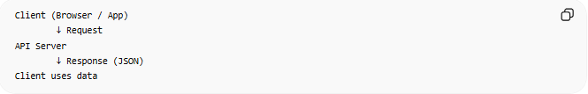
Client (Browser / App)
↓ Request
API Server
↓ Response (JSON)
Client uses data

📥 JSON in API Response (Server → Client)
# Source: AI Source: Provided by: [Data Path: Persons Table -> ID Column: 1, Name_En Column: Motasem Essam] -> From: [ChatGPT] on [5/31/2026]
When you request data from an API, the server sends JSON.
Example:
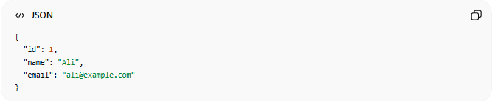
{
"id": 1,
"name": "Ali",
"email": "ali@example.com"
}

📤 JSON in API Request (Client → Server)
# Source: AI Source: Provided by: [Data Path: Persons Table -> ID Column: 1, Name_En Column: Motasem Essam] -> From: [ChatGPT] on [5/31/2026]
When sending data (like login or signup):
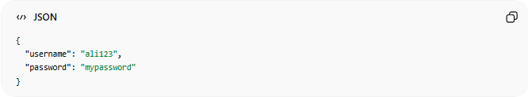
{
"username": "ali123",
"password": "mypassword"
}

🌐 REST APIs and JSON
# Source: AI Source: Provided by: [Data Path: Persons Table -> ID Column: 1, Name_En Column: Motasem Essam] -> From: [ChatGPT] on [5/31/2026]
Most REST APIs use JSON for communication:
- GET → read data (JSON response)
- POST → create data (JSON request)
- PUT → update data
- DELETE → remove data

🔢 REST API Methods with JSON

📥 GET (Read Data)
# Source: AI Source: Provided by: [Data Path: Persons Table -> ID Column: 1, Name_En Column: Motasem Essam] -> From: [ChatGPT] on [5/31/2026]
🌟 Meaning
Used to get data from a server
📦 Example Response:
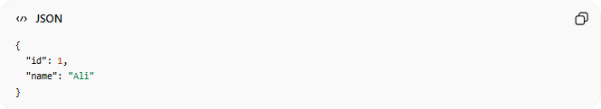
{
"id": 1,
"name": "Ali"
}

➕ POST (Create Data)
# Source: AI Source: Provided by: [Data Path: Persons Table -> ID Column: 1, Name_En Column: Motasem Essam] -> From: [ChatGPT] on [5/31/2026]
🌟 Meaning
Used to send new data to the server
📦 Example Request:
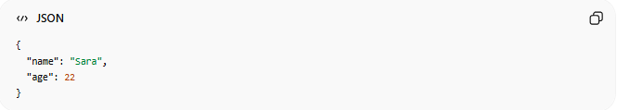
{
"name": "Sara",
"age": 22
}

✏️ PUT (Update Full Data)
# Source: AI Source: Provided by: [Data Path: Persons Table -> ID Column: 1, Name_En Column: Motasem Essam] -> From: [ChatGPT] on [5/31/2026]
🌟 Meaning
Used to replace an entire resource
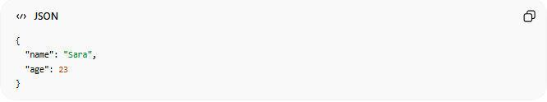
{
"name": "Sara",
"age": 23
}

🔧 PATCH (Update Part of Data)
# Source: AI Source: Provided by: [Data Path: Persons Table -> ID Column: 1, Name_En Column: Motasem Essam] -> From: [ChatGPT] on [5/31/2026]
🌟 Meaning
Used to update only specific fields
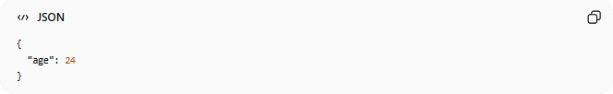
{
"age": 24
}

❌ DELETE (Remove Data)
# Source: AI Source: Provided by: [Data Path: Persons Table -> ID Column: 1, Name_En Column: Motasem Essam] -> From: [ChatGPT] on [5/31/2026]
🌟 Meaning
Used to delete a resource
(No JSON body usually)

📡 HTTP Headers with JSON
# Source: AI Source: Provided by: [Data Path: Persons Table -> ID Column: 1, Name_En Column: Motasem Essam] -> From: [ChatGPT] on [5/31/2026]
When sending JSON, servers expect:

Content-Type: application/json
👉 This tells the server:
“This request contains JSON data”

🌐 JSON in REST API Flow
# Source: AI Source: Provided by: [Data Path: Persons Table -> ID Column: 1, Name_En Column: Motasem Essam] -> From: [ChatGPT] on [5/31/2026]
Client → HTTP Request → Server → JSON Response → Client

⚙️ REST + JSON Structure Rule
# Source: AI Source: Provided by: [Data Path: Persons Table -> ID Column: 1, Name_En Column: Motasem Essam] -> From: [ChatGPT] on [5/31/2026]
- Same URL
- Different HTTP methods
- JSON used for data exchange
Example:
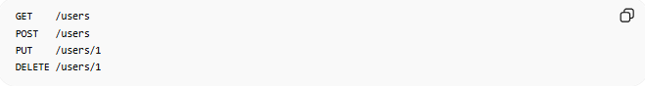
GET /users
POST /users
PUT /users/1
DELETE /users/1

🧠 Simple Idea
# Source: AI Source: Provided by: [Data Path: Persons Table -> ID Column: 1, Name_En Column: Motasem Essam] -> From: [ChatGPT] on [5/31/2026]
Think of REST APIs like:
📦 A restaurant system
- GET = view menu 🍽️
- POST = place order 🧾
- PUT = change order ✏️
- DELETE = cancel order ❌
- JSON = order details 📦

⚠️ Why JSON is used in REST APIs
# Source: AI Source: Provided by: [Data Path: Persons Table -> ID Column: 1, Name_En Column: Motasem Essam] -> From: [ChatGPT] on [5/31/2026]
- Lightweight
- Easy to read
- Fast communication
- Works with all programming languages

🧭 Summary
# Source: AI Source: Provided by: [Data Path: Persons Table -> ID Column: 1, Name_En Column: Motasem Essam] -> From: [ChatGPT] on [5/31/2026]
JSON in REST APIs is used to send and receive structured data between clients and servers using HTTP methods like GET, POST, PUT, and DELETE, making modern web communication possible.

📚 Real API Example
# Source: AI Source: Provided by: [Data Path: Persons Table -> ID Column: 1, Name_En Column: Motasem Essam] -> From: [ChatGPT] on [5/31/2026]
You can test JSON APIs here:
JSONPlaceholder Users API
Response example:
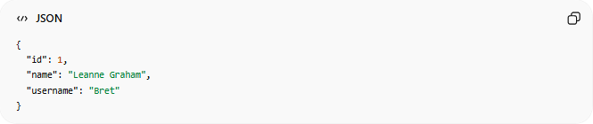
{
"id": 1,
"name": "Leanne Graham",
"username": "Bret"
}

🧠 Simple Idea
# Source: AI Source: Provided by: [Data Path: Persons Table -> ID Column: 1, Name_En Column: Motasem Essam] -> From: [ChatGPT] on [5/31/2026]
Think of JSON in APIs like:
📦 A delivery package
- Request = sending an order form 📄
- Response = receiving a package 📦 (JSON data)

⚠️ Why JSON is important in APIs
# Source: AI Source: Provided by: [Data Path: Persons Table -> ID Column: 1, Name_En Column: Motasem Essam] -> From: [ChatGPT] on [5/31/2026]
- Easy to read and write
- Lightweight (fast)
- Works in all programming languages
- Standard for modern web communication

🧭 Summary
# Source: AI Source: Provided by: [Data Path: Persons Table -> ID Column: 1, Name_En Column: Motasem Essam] -> From: [ChatGPT] on [5/31/2026]
JSON in APIs is the main format used to exchange data between clients and servers, where requests and responses are structured in JSON for easy and efficient communication.

